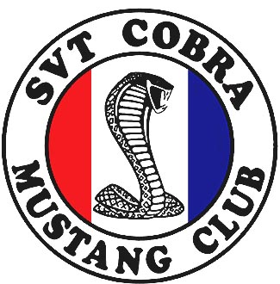

SCMC Autocross
411 Speedway
Maryville, TN

Sunday – April 9, 2006
Sunday – June 25, 2006
Sunday – August 27, 2006

Gates Open: 7:00
Tech: 8:00-9:00
First Car Off: 9:30

This event is limited to the first 36 vehicles registered. Registration is considered complete when your registration form and fee of $35.00 per event is received. Please send the Form below along with the registration fee to:

SCMC TN Autocross
122 Landhaven Way
Harriman, TN 37748

Upon receipt of your registration fee we will post your name in the SVTCobraClub.com Upcoming Events Forum. Any questions contact Rick McNutt: 865-712-5062

Name

Address

City State Zip

Phone Vehicle
Year make/model

E-mail Address_______________________ Car Number (optional)_________________

I hereby understand that I am responsible for my automobile and contents and agree to hold harmless and release 411 Speedway, SVT Cobra Mustang Club of liability for any damage, personal injury or loss of property during the SCMC Autocross.

Signature _______________________________________________________Date__________________

Check one of the following:

Novice (3 events or less) ______

Experienced ______

Experienced w/Race Tires ______
Check dates you wish to attend
April 9, 2006
June 25, 2006
August 27, 2006
Early get all three $90.00 ______
Fee Enclosed ___ x $35.00 = ______
Add $10 Late Fee <10 days Prior

