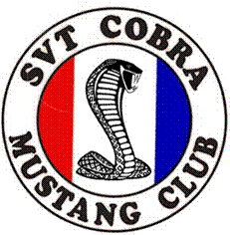
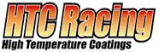


The SVT Cobra Mustang Club, MPE Racing and HTC Racing
ANNOUNCE THEIR FIRST ANNUAL NEW ENGLAND REGION
SVT COBRA , MUSTANG & ALL FORD SHOW
September 16, 2006 - Whitman, MA
Rain date September 17

September 16, 2006: 9 a.m. - 11 :00 a.m. Registration/Set up
11 :00a.m. - 1 :00p.m. Judging (To Be Done by SCMC Rules)
1 :00 p.m. - 2:00 p.m. Awards Presentation
SVT Cobra Classes*
93 –01 Stock_____93-01 Personalized______
93-01 Modified_______ 2003/2004 All_ ____
Saleen, Roush, Steeda, Shelby, GT and Mustang Classes
65-73 Mustang______ 74-93 Mustang_____
94-98 Mustang______ 99-06 Mustang_____
Lightning/Truck Class_____
Focus/Contour/Other_____ Display (non – judged)________
(The SCMC reserves the right to combine classes based on the number of participants.)
*SVT Cobra Classes
Stock – 2 visual mods or less Personalized – 3 to 7 visual mods
Modified – 8 or more visual mods, or any of the following: full body kit, supercharger, nitrous
REGISTRATION (Please Print)
Name: E-mail Address

Mailing Address:

City State Zip Code

Model Year Body Style VIN# Color
For directions call MPE Racing 781-447-1123

I agree to abide by all rules and regulations of the SVT CobraMustang Club (SCMC) and understand that I am responsible for my car and merchandise. I agree to release from all liability MPE Racing, HTC Racing, the SVT Cobra Mustang Club, and any of its officers, sponsors or affiliates for any damage, injury, lost, or stolen merchandise from this event.

Signature: Date: Phone:

The SVT Cobra Mustang Club is not affiliated with Ford SVT, Ford Motor Company or any of its subsidiaries.

