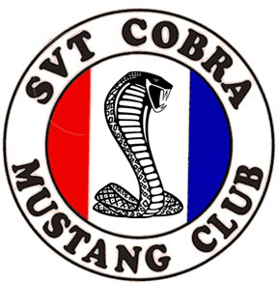SCMC New Member Application
WWW.SVTCOBRACLUB.COM ----- CLUB TELEPHONE: 803-371-0725

Personal Information: (Please Print Clearly)

Name:

Address:

City: State: Zip Code:
Country: Phone Number:

*E-mail Address*:

(IMPORTANT, PLEASE READ: Most club contact will be through e-mail, including an initial welcome message detailing club benefits, weekly club updates, and a link to the quarterly newsletter which you must download from your computer. If you choose to pay $20.00 in dues, it is essential that you include a valid and complete e-mail address in order to receive full club benefits.)

I like the following: (Circle all that apply.)

Autocross Open Track Drag Racing Car Shows Cruises

I am also a member of the following other clubs: (List any other clubs of which you are a member.)

Car Information: (Please note: You must own a Ford SVT Mustang Cobra to join the SCMC.)

Type: Color: Year:
(Coupe/Convertible/Hatchback)

Valid Cobra VIN Number or attach copy of Certificate of Authenticity for the vehicle that you want listed in the club directory:

Membership Dues: (Please choose based on how you wish to receive your newsletter.)

$20.00 annually (Canada $25.00 US Funds) Internet access is required as quarterly Newsletter will be sent via e-mail link that you must download from your computer using Adobe Acrobat Reader (available at no charge from:http://www.adobe.com/products/acrobat/readstep.html)

$30.00 annually (Canada $35.00 US Funds) Printed Newsletter will be sent via US Post Office.

Membership packets include: Quarterly newsletter, windshield decal, Officer directory, and membership card. Please visit our club store at www.scmcstore.com.

MAIL YOUR DUES (US Funds Only) WITH CHECKS MADE PAYABLE TO "SCMC"TO:
SCMC/ 1642 HUNTMOOR DRIVE/ ROCK HILL/ SC /29732

Save money, postage, and time by signing up for multiple years:

1 year via e-mail - $20.00 2 years - $30.00 Each additional year, add $15.00
1 year via USPS - $30.00 2 years - $50.00 Each additional year add $25.00

Other benefits for dues paying members include: Quarterly Snakebite newsletter (see above for details); mailing lists, bulletin board, classified ads, major vendor discounts, club mailboxes, pictures of your car on the website, and more.

SCMC is a non-profit organization and is in no way associated with Ford SVT.
Mail any correspondence to SCMC, 1642 Huntmoor Dr, Rock Hill, SC, 29732 (e-mail: mrmach@cetlink.net; Telephone: (803) 371-0725)

