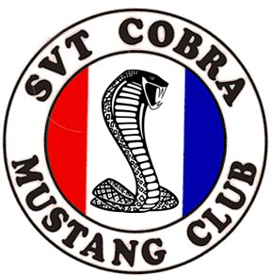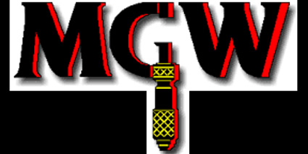

_____________
Car Number

SCMC/MGW Fall Drag Day & Top 25 Mustang & Ford Show

The date of this event is November 4, 2006 at the Carolina Dragway in Jackson, SC. This event is sponsored by MGW Ltd, Inc, and SCMC, Inc. Car show is sponsored by Pro-Dyno & MM Performance.

Personal Info

Name:____________________________________ Email Address:__________________________

Mailing address: ______________________________________Phone: ___________________________

Car Info: (Convertibles will require rollbars for drag racing)

Year:___________ Color: ____________________________ Body Style (Coupe/Vert):___________

Naturally Aspirated, Supercharged, or Nitrous: ______________

Enrollment postmarked on or before 10/23/06

Member Fee or previously attended this event for drag day: $35.00
Non-Member Fee or has not previously attended this event/first timer: $40.00
Spectators: $ 5.00
Top 25 Car Show $20.00

Total Enclosed: _______

Discounts for drag day for the following groups:

I am participating as a guest of SCMC ________ SCMC Number ______
I have previously attended this event ________
Neither criteria/First timer ________

Enrollment postmarked 10/24/06 or later

All Participants including SCMC members: $50.00

Amount enclosed:_______________

Make checks payable to SCMC and mail to:

SCMC
1642 Huntmoor Dr
Rock Hill, SC. 29732

I agree to abide by all rules and regulations of the SVT Cobra Mustang Club (SCMC). I understand that I am responsible for my car and merchandise. I agree to release from all liability Carolina Dragway, MGW LTD Inc, Pro-Dyno and it’s officers and the SVT Cobra Mustang Club and it's officers for any damage, personal injury, lost or stolen merchandise resulting from this event.

Signature: ____________________________________ Date: _____________________
The SVT Cobra Mustang Club is not affiliated with Ford SVT, Ford Motor Company or any of its subsidiaries.

