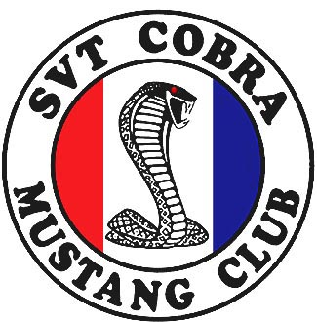

www.SVTCobraClub.com
Autocross/Driving School
Ft. Devens
Shirley, MA

Event dates:
April 28, July 7, Aug 4, Oct 21

Upon receipt of your registration you will be sent (email) info that includes itinerary, directions to the site, general info regarding what to bring and basic car set up.

Contact:
Pat Madigan – SCMC NE Rep
PMad300hp@aol.com
617-827-9789 cell
_ _ _ _ _ _ _ _ _ _ _ _ _ _ _ _ _ _ _ _ _ _ _ _ _ _ _ _ _ _ _ _ _ _ _ _ _ _ _ _ _ _

Name:______________________________________________________________
Address:_____________________________________________________________
City:______________________________State:________ Zip:__________________
Phone: _____________________Email(write clearly):_________________________
Vehicle Make:_________________Model:_________________Year:_____________
Car Number (optional):_________________ Member # (required for discount)_________
Mustang Classes:  Experienced Mustang  Experienced Mustang Race Tires*
Non Mustang Classes:  Rear Wheel Drive  Front Wheel Drive  All Wheel Drive
 Novice (Any driver with 3 events or less experience)
*Race Tires are defined as any tire with a 150 treadwear rating or less

Dates: Fee**: Send to:

Apr 28 $55 one event SCMC Autocross
July 7 $105 two events c/o Pat Madigan
Aug 4 $150 three events 295 Summit Rd
Oct 21 $195 four events Abington, MA 02351

** Club members get $5 discount per event if registration is postmarked 2 weeks before the first event (April 14).

